

Dr. Jeremy, Singh inc.
2020-06-22
Dr. Singh
193 Gutierrez Stream, Wrighttown, NC 14657
Phone: 4170038610
Fax: 5869811173

Re: Sandra, Jones
PHN: 627310953
Birthdate: 06-Nov-1961
Address: 2820 Kevin Cliffs Suite 242, New Johnburgh, NY 73820
Patient number: 4647489583

To Whom It May Concern:

This is a medical letter to state the above patient is pregnant with expected delivery date of 27-Aug-2025. Hoping this information is satisfactory for your requirements.

Thank you.

Sincerely,
Dr. Jeremy, Singh
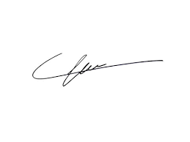
FRCS© NCMP
Clinical Assistant Professor, UBC
Department of Obstetrics and Gynecology SMH

